**Current Township Hall Model**

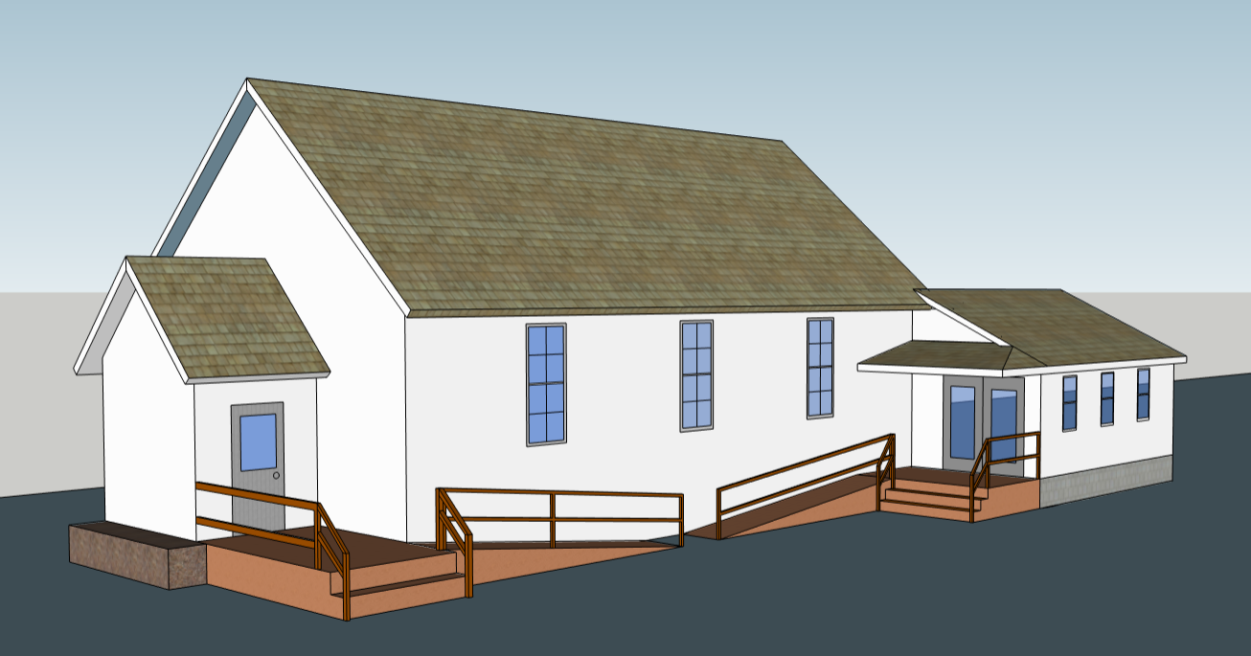

**Drawing Information**

* This model is just to show different visual package options of design for a porch/roof that is covering railings/decks.
* Several different models will be shown.
* No dimensions will be listed on this print (modeling only for a visual idea)
* Models implement no changes in porches/decks.
* Only changes in building will be added roof cover and changes to match front entryway with a clean build and roof match.

**Prints By**:

All Prints and models done by *Brad Byard*. Please contact [bradleybyard@gmail.com](mailto:bradleybyard@gmail.com) for additional information, ideas, changes, or quotes.

**NOTE:**

All building details may not be shown in each drawing,

**MODEL 1**

**FRONT**

**SIDEVIEW**

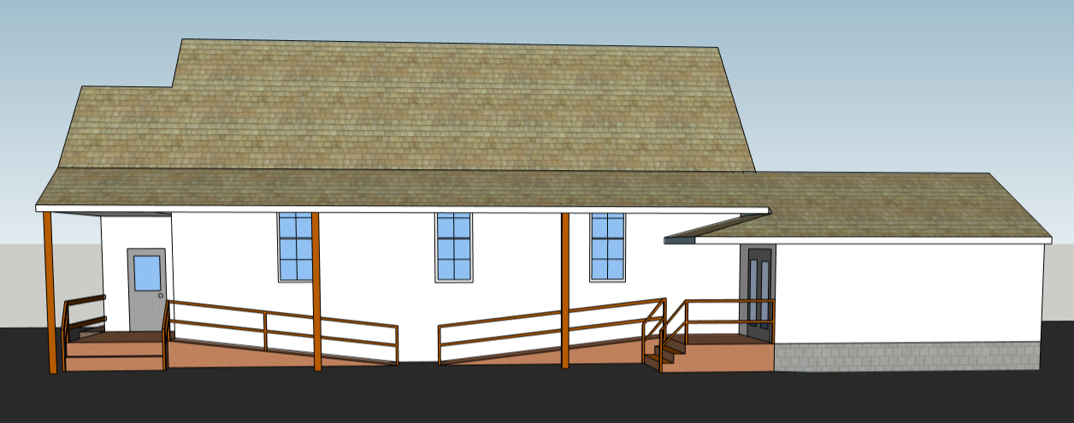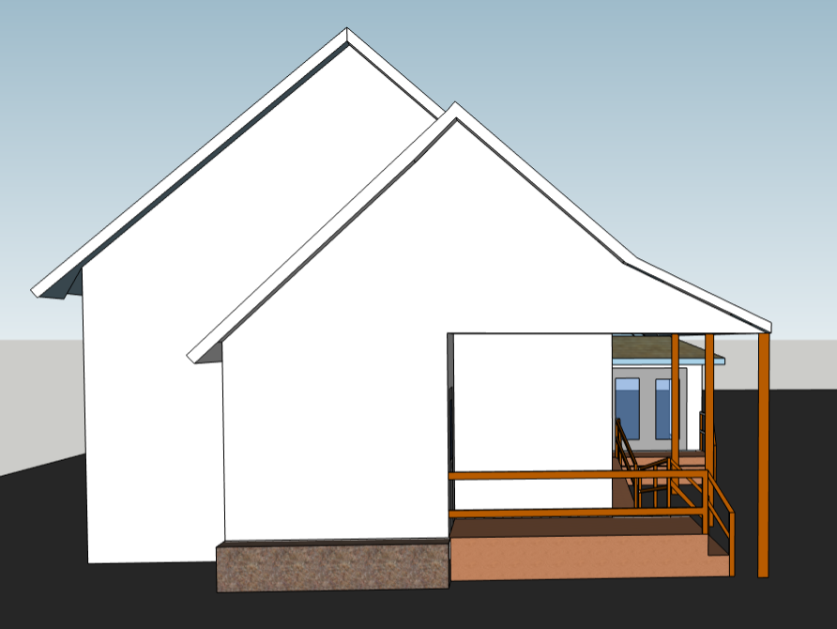

**ANGLED VIEW 2**

**ANGLED VIEW 1**

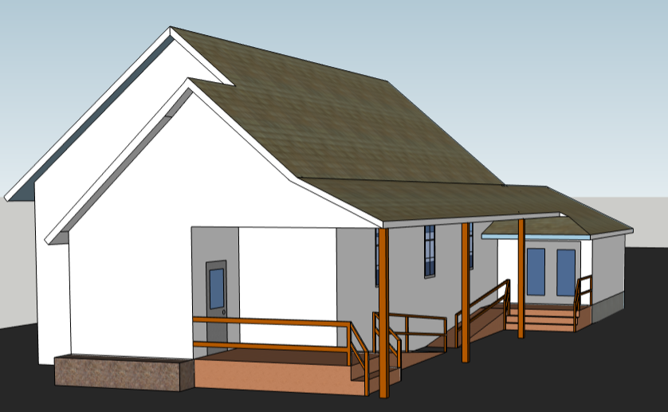

**Key Notes**

* Double door mini roof remains the same
* New Porch roof follows rear addition pitch.
* 3 Support poles added
* Porch overhangs outside of building by about 6’
* Front porch roof extends to match pitch.
* More support poles may be needed (Per code)

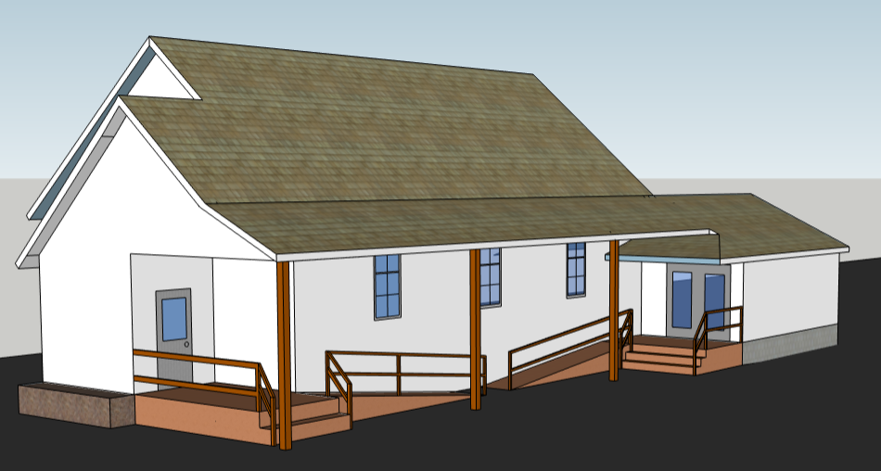

**MODEL 2**

**ANGLED VIEW 1**

**SIDEVIEW**

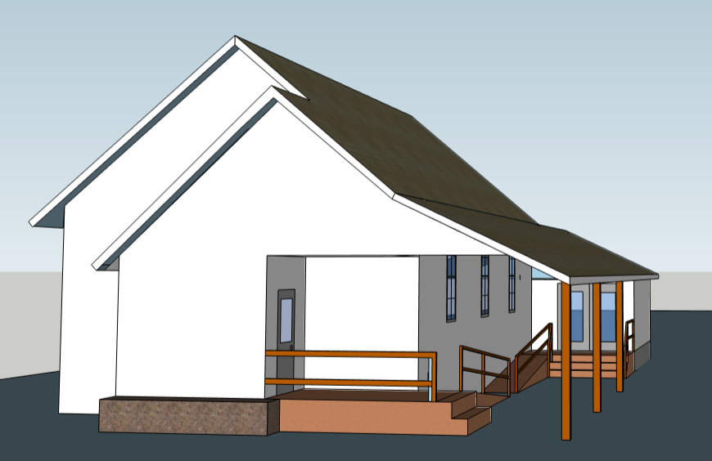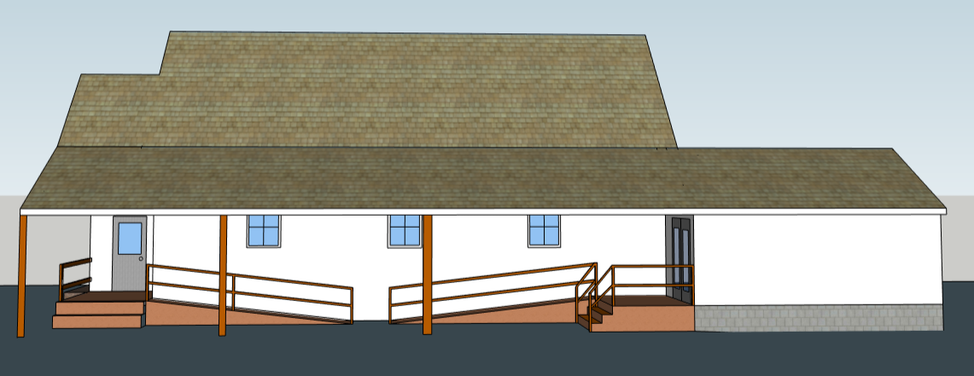

**Key Notes**

* New porch roof takes rear addition roof and extends that entire pitch the full way down the building.
* Note in sideview how roof extension is smooth for the full span
* Approximate overhang is of new roof is 10’
* 3 support poles out about 6’ from the walkway.
* Biggest roofed model shown
* More support poles may be needed (Per code)

**ANGLED VIEW 2**

**FRONT**

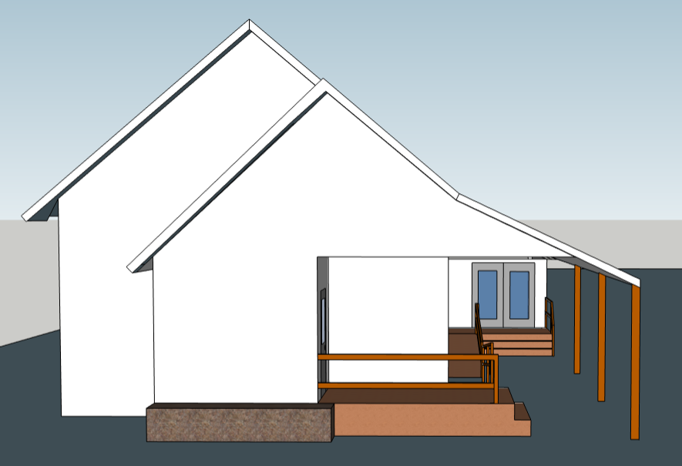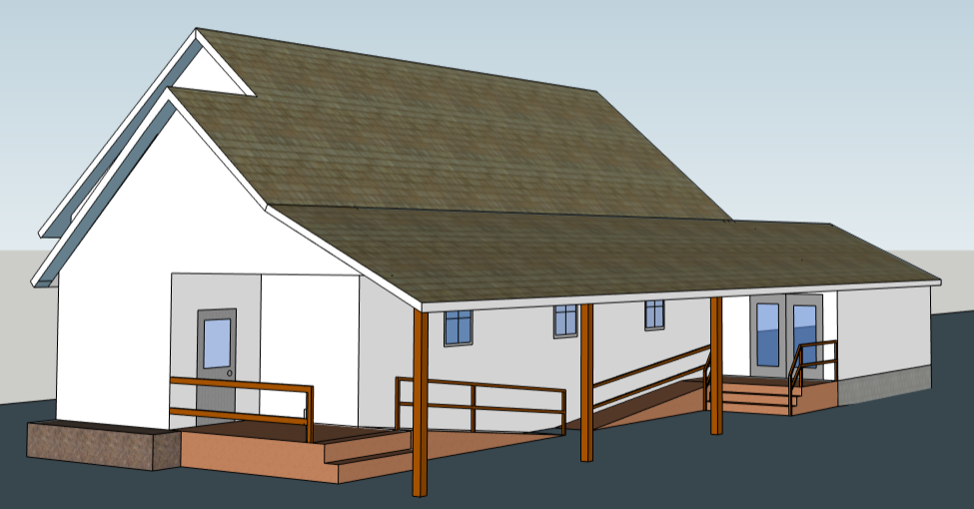

**MODEL 3**

**ANGLED VIEW 1**

**SIDEVIEW**

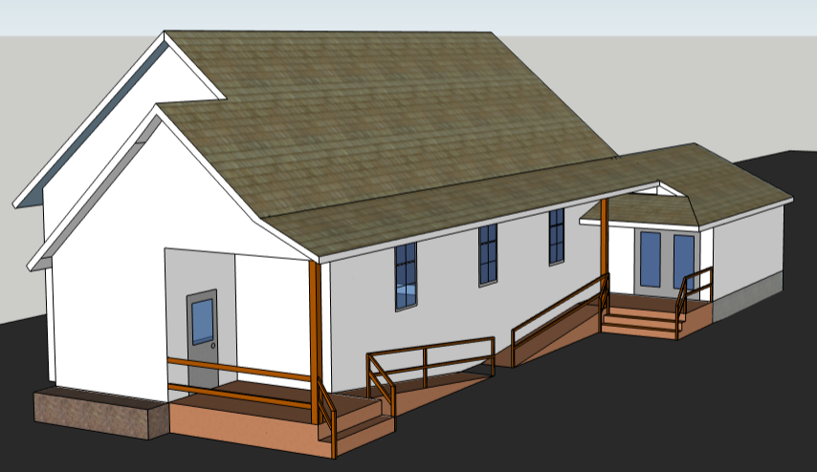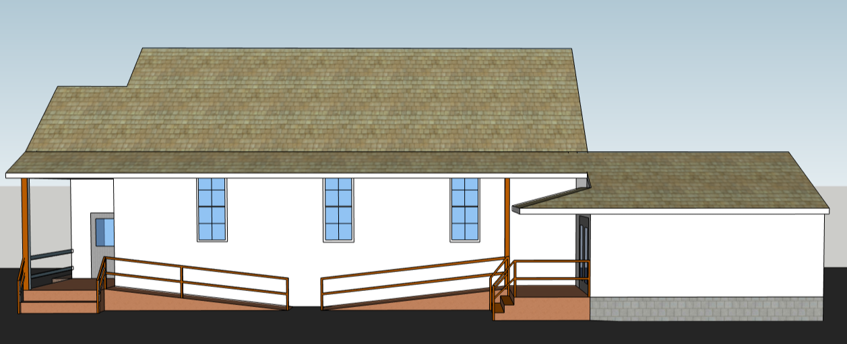

**ANGLED VIEW 2**

**FRONT**

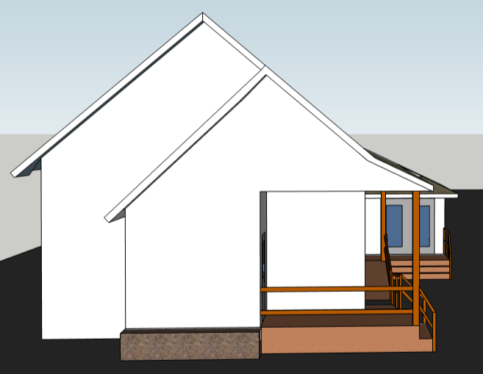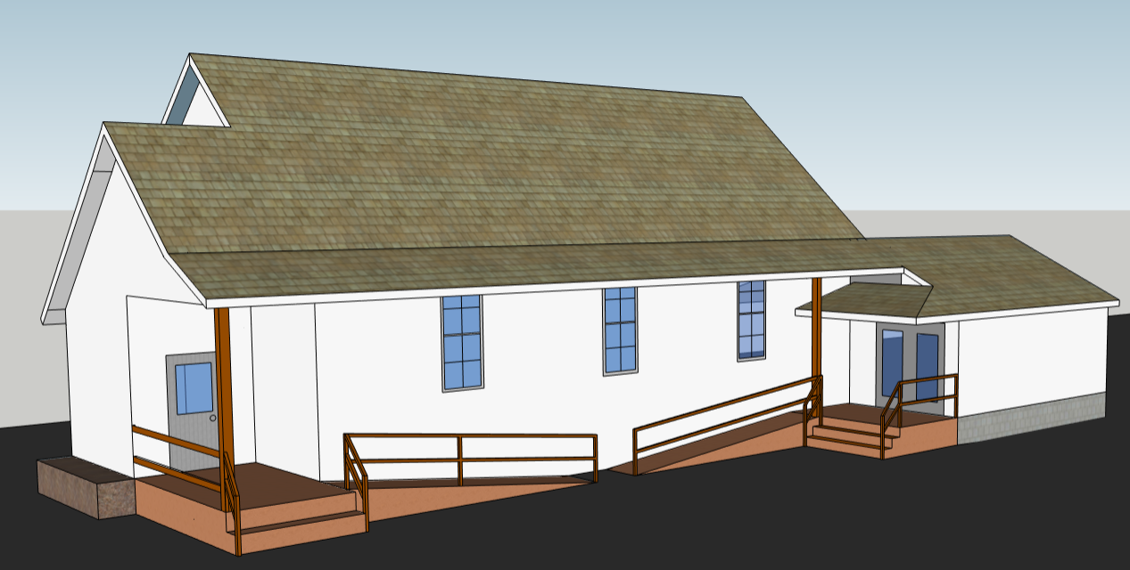

**Key Notes**

* Similar to Model 1 main difference is roof overhang is shorter, just enough to cover walk ways.
* Support poles come off the deck and not the pavement, and are closer to building.
* Approximate overhang is 4’, slightly overhangs railing
* More support poles may be needed (Per code)
* Cheaper Option

**MODEL 4**

**ANGLED VIEW 1**

**SIDEVIEW**

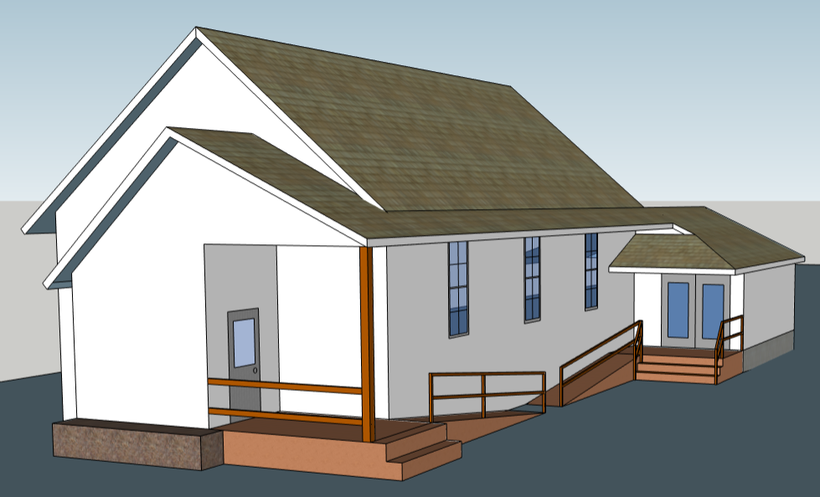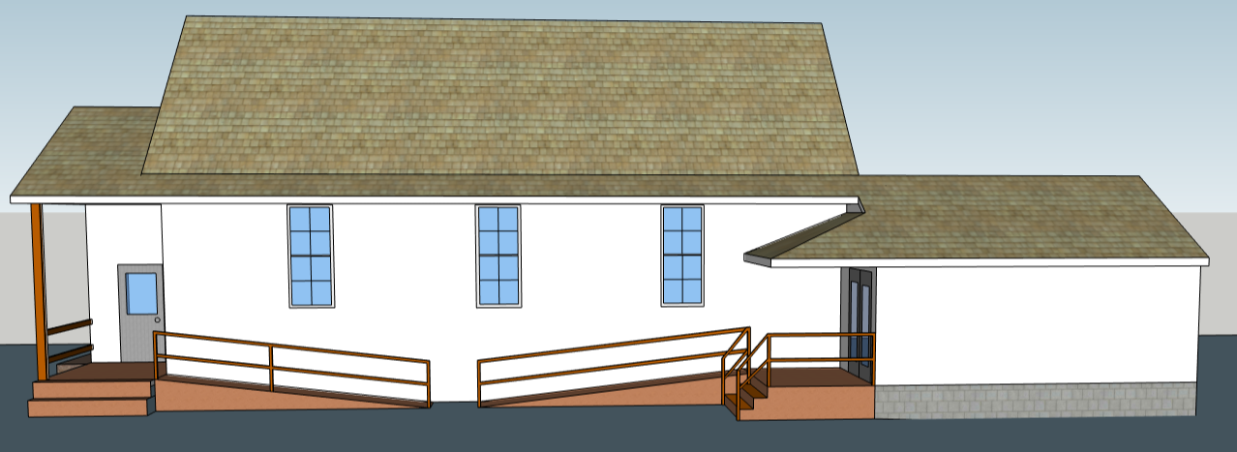

**ANGLED VIEW 2**

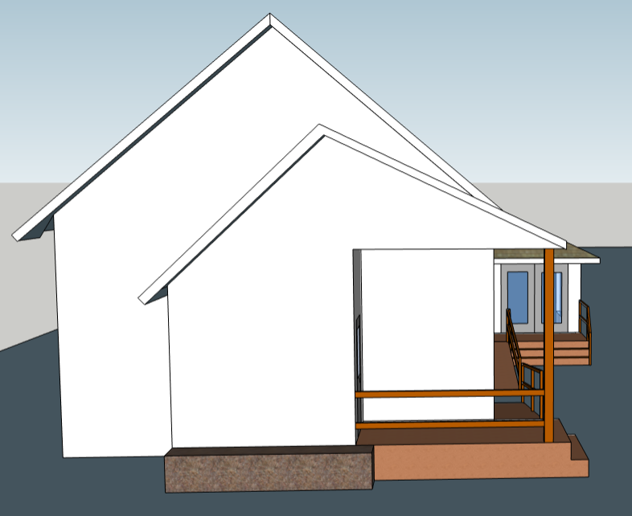

**Key Notes**

* Rear addition roof pitch follows the building all the way up the side and matches that pitch with pitch of entryway/town hall, so entryway has 2 different pitches
* Shorter roof covering approx., 3’6” (just enough to full cover walkway)
* Only one support pole (due to less load to support above.
* More support poles may be needed (Per code)
* Probably cheapest option.

**FRONT**

